Stavin Vas

URL:

<https://public.tableau.com/profile/stavin.vas#!/vizhome/Book2-A1/Story2>

Dashboard 1:

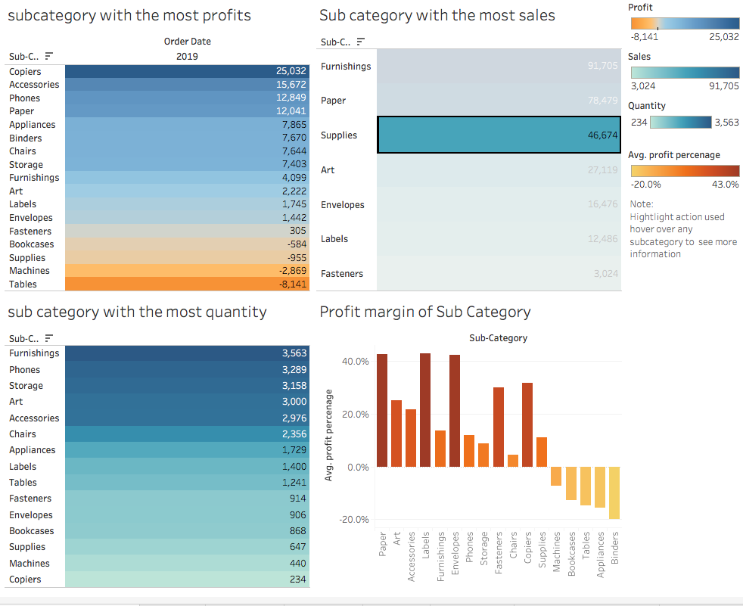

Dashboard 2:

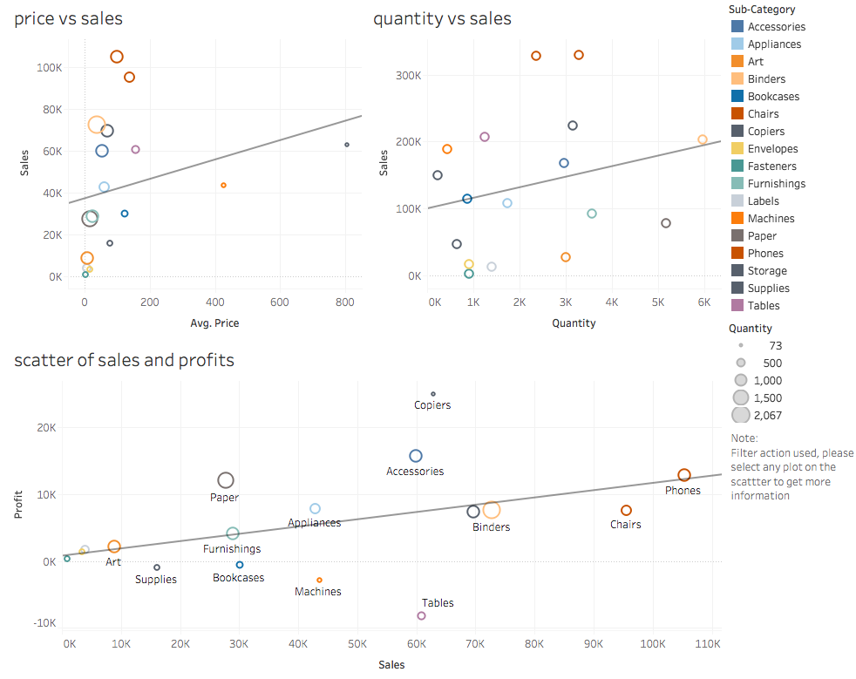

Dashboard 3:

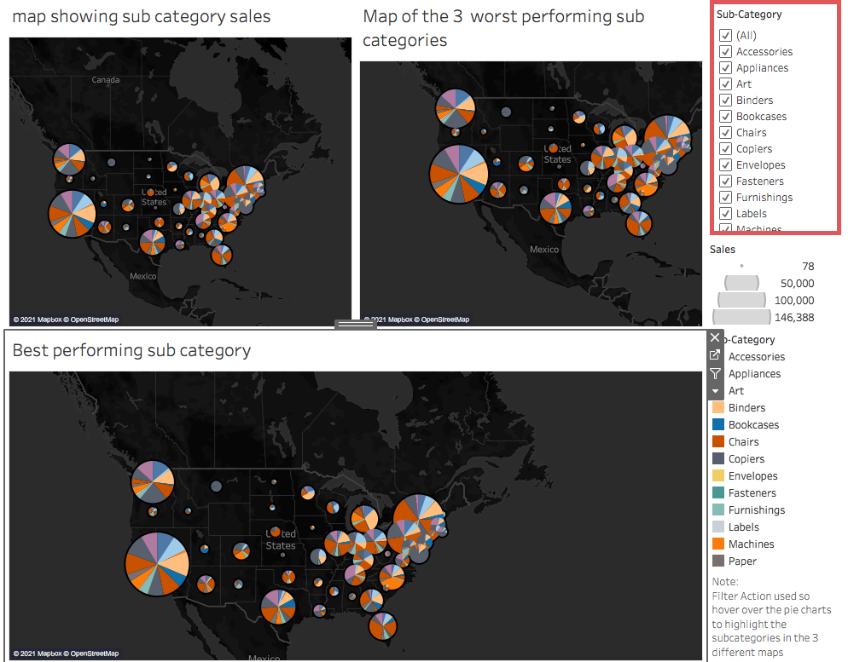

**Business Insight Report**

This report will look at the sales of subcategories and look at specific sales, strategies and regions that we need to target to bolster sales in specific sub-categories to maximise profit. First, we will look at the dashboards, why these visuals were created and what insights we can gain from them. Following on from that we will look at the underlying problems related to sales and the implementations that we can put in place.

**Dashboard 1:**

When we look at the breakdown of the performance in Dashboard 1 we can see that copiers had the biggest profit margin, followed by accessories and phones. When looking at the sales we can see that that phones, chairs and binders had the most sales and Labels, envelopes and Fasteners had the least amount of sales. However, when you look at the scatterplot of sales vs profits, you can see that the sales of bookcases, machines and tables have got a very negative profit margin. The reason why I chose to have a breakdown of the performance in Dashboard 1 is to have a look at how each subcategory ranked in order and so I can pick the top 3 subcategories and the bottom 3 subcategories in terms of sales so that I can compare them and gain some insights.

**Dashboard 2:**

When we look at the second dashboard which contains three scatter graphs which the first scatter plot looks at price vs sales: this is because we want to see how the sales deviate when the average price is low or high so we can get an insight as to if the superstore is attracting value-seeking customers or price-savvy customers. The second scatter shows us quantity vs sales which has been done to gain an insight as to if a bigger quantity leads to more sales. However, if you look at the second dashboard you can see that the scatter does not head into a positive or a negative direction, instead, it is scattered all around the place. This is showing us that there is no correlation between several quantity and sales so therefore we can eliminate the quantity variable. Finally the last scatter plot looks at the sales and profit. This was done to see if more sales led to more profit. By looking at the graph we can see that more sales volume did not lead to more profit so therefore we can now assume that there is some underlying strategic problem within the sales.

**Dashboard 3:**

The final dashboard is a map comparison that looks at the different subcategories of sales in different states. There are an additional two maps that show the sales region of the three best categories and then another map shows the sales region of the three worst-performing subcategories. The sales map show us that the three best-performing subcategories have got higher sales volumes in general, especially in the bigger sized states such as California, New York and Washington. The bigger states such as California, New York and Texas are also the most populated in the US. There is a bit of a gap between sales of the best three and the worst three categories in the bigger and more populated states. From a marketing perspective, you would want to aim your products at the mass market so that your products gain as much attention as possible. We will be getting into this deeper in the recommendations section.

Even though sales-wise the three worst-performing subcategories that I chose are not the worst-selling sub-categories, but if it is harming the profit margin like they are then it is definitely a cause for concern. Judging by the data so far it does not look like there is an issue with the volume of sales but rather there could be some strategic issues maybe with the pricing, marketing or strategies that are causing negative profit margins.

Low revenues where the sales decreases below the amount of money spent on purchasing the goods will usually result in a net loss. There could be other factors coming into play such as poor pricing strategies, competition, not keeping up with the current market and not effective marketing strategies/campaigns.

**Problems + Recommendations**

In this problems and recommendations section of this report, we will focus on the three worst-performing sub-categories which are machines, bookcases and tables and look at the sales of these subcategories in different regions and potentially figure out what states/cities we can target and the different marketing strategies that we can use to increase sales so that we can bolster profit. If you have a look at the dashboard which contains the sales map of the best and worst-performing subcategories, you can see that in the more populated states such as New York, California, Washington and Texas that the number of sales is significantly higher for the best performing subcategories than it is for the worst-performing subcategories. By targeting customers in the more populated areas, your products are exposed to more target markers, which will attract more sales. The sales map indicates that there isn’t much of a difference between the sales of the best performing and worst-performing categories within the more rural states such as Alabama and Mississippi. However the issue there is that sales numbers are a lot lower in comparison to the more populated states such as California and New York. This indicates that in the more rural regions there perhaps there isn't a heavy demand for these products or maybe in the rural areas the superstore is in a location that is not feasible. Location is very important as it needs to be feasible for all kinds of customers. More than the subcategories in different regions need to be analyzed too. If there isn't a high demand for certain subcategories such as bookcases in the more rural regions then perhaps it is best not to have them in certain stores. The aim of marketing in physical retail stores is to have the most in-demand products in the most optimal places. There is no need to have certain products in certain regions because it will just be taking up space and costing more money, which at the end of the day bites into the profits.

The scatterplot of sales vs profits shows us that sales and profits are not directly correlated with one another. You can have high volumes of sales but you can still be making a loss when it comes to profit. Effective pricing strategies are required to make sure that you are not making a loss on your sales, which is ultimately impacting your profit margins. To determine effective pricing strategies, you need to determine your competition, the expenses involved with purchasing the goods and the amount of profit margin that you would like to earn. The scatterplot “price vs sales” shows us that there is a big cluster around the lower end of the price scale and that is leading to a higher amount of sales. The superstore has taken a low pricing approach by the looks of the plot, however that approach can affect sales volumes for good or for bad. Low pricing can sometimes give customers the perception that the quality of a product is too low and that reflects the quality of the product. Value seeking customers will be very hesitant to purchase such products and that can harm sales. On the other hand, if a product is priced too high then price-savvy customers will be hesitant to purchase the product. Therefore It shows the need for price optimization, To do that market research will have to be conducted and further data will be needed to evaluate the optimal pricing strategy for the Superstore, which requires money hence the need for budget allocation to help with market research to improve sales and profits.

**Conclusion:**

Overall we have determined that the volume of sales is not the biggest concern. Sales are relatively steady throughout the three worst-performing subcategories, there are strategic problems that are the concern. We should always try to maximize sales, even if they are steady. However, along with trying to maximize sales, we need to make sure we strategically price each product and that we market effectively. To do that we need to conduct market research to get to know what customers in different states would pay so that we can find the optimal prices accordingly. Another thing that we need to gain insight into is the demand for the products in different regions, there is no point in having products on the shelf if they are not selling in enough volume to make profits. Finally, in terms of marketing, we see that there is a steady ship of sales in the more populated states but compared to the best performing subcategories there is a sizeable gap between the volume of sales. Therefore by effectively marketing the worst-performing subcategories, we can attempt to aim the products to the mass market to boost sales. Overall the budget is needed to conduct more market research for price strategy and optimization as well as for marketing in the more populated and bigger regions.